FOR IMMEDIATE RELEASE

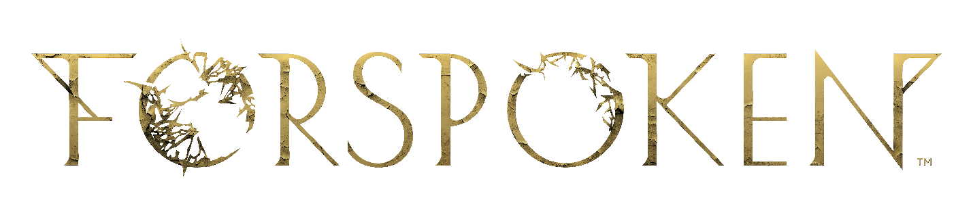
SQUARE ENIX AND LUMINOUS PRODUCTIONS REVEAL NEW FORSPOKEN STORY TRAILER

First Story Trailer Showcases New Details About Protagonist Frey Holland,
Reveals More Characters, Hollywood Talent, and a Spring 2022 Release Window

LONDON (Sept. 9, 2021) – SQUARE ENIX® today unveiled a new story trailer and official Spring 2022 release window for Luminous Productions’ debut title, Forspoken. The new footage reveals more details about the protagonist Frey, a directionless, gritty yet street smart young woman who has persevered despite her rough upbringing in New York City.

Watch the new Forspoken story introduction trailer here: https://youtu.be/NYYgSs2RkJQ

The new story trailer also gives fans a closer look at Forspoken’s magic-infused combat and swift, dynamic movement, playing a key role in gameplay. Through the course of her journey, Frey will learn to cast and harness dozens of different types of magic and cast powerful spells as she traverses through the beautiful yet cruel land of Athia. Frey’s quest in Athia will take her through a variety of diverse environments where she will use magic enhanced parkour. This dynamic and acrobatic movement, enhanced by Frey’s mystical abilities, enables her to magically flow, zip and float across the vast landscapes of Athia in a fast and fluid manner.

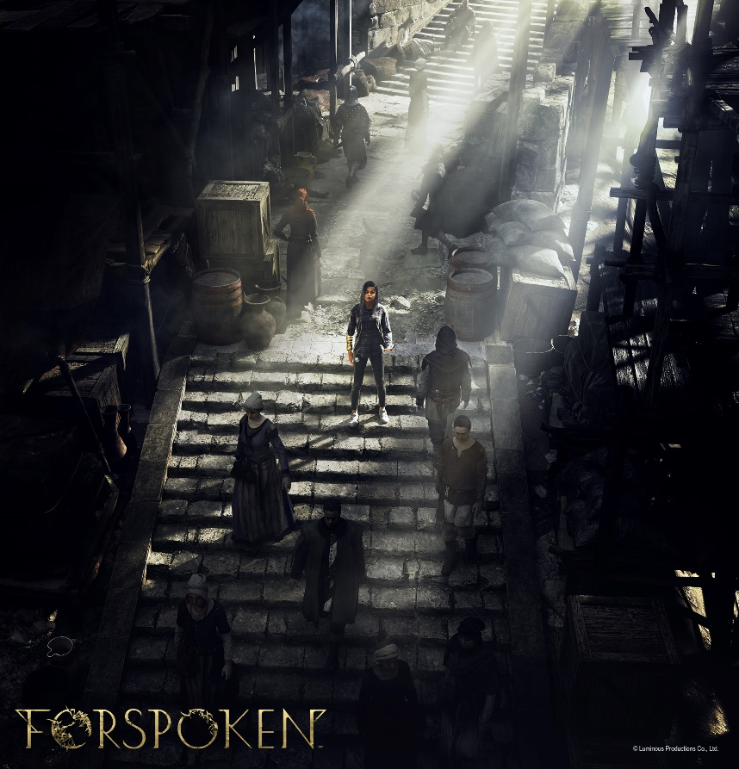

Other key characters in Forspoken are highlighted in the trailer, including Frey’s companion ‘Cuff,’ a magical sentient bracelet, voiced by actor Jonathan Cake (Stargirl), who helps her navigate the sprawling landscapes of Athia. Players are also introduced to Tanta Sila, a maddened and evil ruler who is the strongest and most formidable Tanta, or matriarch, in Athia, as she and Frey face off in an explosive and action-packed battle. Performed and voiced by actress and musician Janina Gavankar (True Blood), Tanta Sila’s debut offers fans a glimpse of the formidable enemies that await in Athia. Keala Settle (The Greatest Showman) and Monica Barbaro (Top Gun: Maverick) also make an appearance as Johedy and Auden, fellow Athians who befriend and assist Frey with her journey.

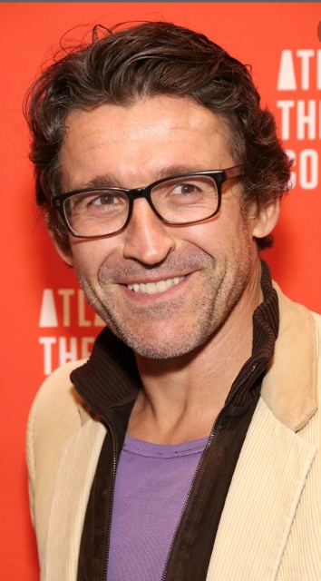
(Jonathan Cake, Janina Gavankar)
(Keala Settle, and Monica Barbaro)
SQUARE ENIX and Luminous Productions worked in collaboration with Hollywood writer Gary Whitta (Rogue One: A Star Wars Story), who conceived the original concept, and award-winning writer/director Amy Hennig (Uncharted series), who developed the story concept in 2019 (prior to heading Skydance New Media). Taking the reins as Lead Writers on Forspoken’s story and script, talented entertainment writers Allison Rymer (Shadowhunters) and Todd Stashwick (Devil Inside) have crafted a thrilling tale about self-discovery and finding out where you belong in the world.

(Allison Rymer)
(Todd Stashwick)

“Writing Forspoken has been a magical experience. The main character Frey is strong, complex and very relatable. I am excited for the players to connect with her.” said Rymer. Stashwick adds “Like Frey, it’s been a long, amazing journey for us. I’m thrilled to finally have people adventure through the story we have built. I’m so proud to be part of this team, giving a contemporary, fun, spin on the fantasy genre.”

SQUARE ENIX and Luminous Productions also unveiled that the score is composed by BAFTA award-winning composers Bear McCreary (God of War (2018) and TV series The Walking Dead) and Garry Schyman (Bioshock series). Together, they set the unconventional tone of the game by immersing players into a world of twisted beauty while fusing contemporary electronic beats with a fantasy tone.

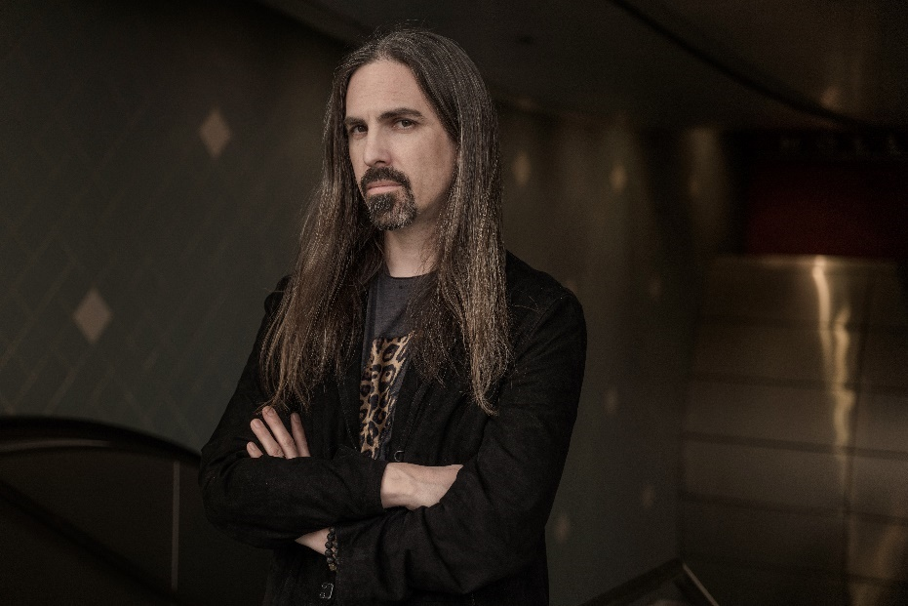
(Bear McCreary)

(Garry Schyman)

“We’re incredibly excited to be working together to compose the soundtrack for Forspoken. When we first read the script for the game, we were moved by Frey’s dynamic character and the contrasting themes of modern and fantasy that run throughout the story, which is something we wanted to reflect in the music we compose for the soundtrack.” said McCreary and Schyman.

All assets including the new key art, CG renders of Frey, Cuff, Tanta Sila, and screenshots are available on the press site at: https://press.uk.square-enix.com/Forspoken

Designed for the PlayStation®5 console (PS5™), Forspoken will harness the full power of the console and demonstrate Luminous Productions’ philosophy to provide a gaming experience like never before, fusing together the latest technology with creativity. The game is being developed simultaneously for the PS5 console and PC (via STEAM® Store, Microsoft Store and Epic Games Store) and is set for release in Spring 2022.

To learn more about Forspoken, visit: www.forspoken.com.

Related Links:
FORSPOKEN Website: www.forspoken.com
Luminous Productions Website: https://www.luminous-productions.com
Facebook: www.facebook.com/Forspoken
Twitter: @Forspoken
Instagram: @Forspoken
#Forspoken

About Square Enix Ltd.
Square Enix Ltd. develops, publishes, distributes and licenses SQUARE ENIX®, EIDOS® and TAITO® branded entertainment content in Europe and other PAL territories as part of the Square Enix group of companies. Square Enix Ltd. also has a global network of leading development studios such as Crystal Dynamics® and Eidos Montréal®. The Square Enix group of companies boasts a valuable portfolio of intellectual property including: FINAL FANTASY, which has sold over 163 million units worldwide; DRAGON QUEST®, which has sold over 83 million units worldwide; TOMB RAIDER®, which has sold over 84 million units worldwide; and the legendary SPACE INVADERS®. Square Enix Ltd. is a London-based, wholly owned subsidiary of Square Enix Holdings Co., Ltd.

More information on Square Enix Ltd. can be found at https://square-enix-games.com.

# # #

© Luminous Productions Co., Ltd. All Rights Reserved

FORSPOKEN. LUMINOUS PRODUCTIONS, DRAGON QUEST, EIDOS, EIDOS MONTREAL, FINAL FANTASY, SPACE INVADERS, SQUARE ENIX, the SQUARE ENIX logo, TAITO and TOMB RAIDER are registered trademarks or trademarks of the Square Enix group of companies. “PlayStation” and “PS5” are a registered trademark or trademarks of Sony Interactive Entertainment Inc. All other trademarks are properties of their respective owners.

