FOR IMMEDIATE RELEASE
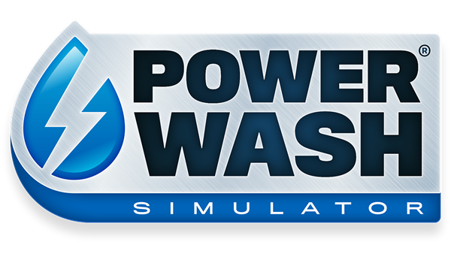
CELEBRATING ONE YEAR OF POWERWASH SIMULATOR WITH THREE NEW LEVELS, CHOSEN BY YOU!

INTRODUCING THREE SPECIAL JOBS SELECTED AND VOTED FOR BY THE COMMUNITY!

LONDON (May 19th, 2022) – Today, award-winning developer FuturLab released a special anniversary update for Steam Early Access title POWERWASH SIMULATOR. Published by Square Enix Ltd, the 0.9 update features three Special Jobs selected and voted for by the PowerWash community!

POWERWASH SIMULATOR lets players wash away their worries with the soothing sounds of high-pressure water. Players can build their very own power washing business and blast away every speck of dirt and grime that they can find. POWERWASH SIMULATOR focuses on player relaxation and escapism with a unique take on the simulation genre.

To mark the first anniversary of the game's release into Steam Early Access, FuturLab has released a selection of community map requests to mark the occasion. Throughout the last 12 months, POWERWASH SIMULATOR has had nine updates and added over 25 new jobs and 2 new game modes; the community has grown to hundreds of thousands and garnered over 18,000 overwhelmingly positive reviews.

The new community maps feature a fabulous Gnome Fountain, a sensational Steam Locomotive, and a magical Mini Golf Course. All three of these Special Jobs were proposed, selected, and voted for on Discord by the PowerWash community from hundreds of suggestions.

"We always knew that community would be a huge part of this game's development, and it was important to us that we engaged with players to gather feedback and ideas to shape the game's future." Commented James Marsden, Co-CEO of FuturLab. "That's why we are particularly excited that this update has key community-driven improvements and three original levels suggested by and voted for by our players. One year on this game is still exceeding our expectations, and we can't wait to show you what's next."

That's not all for this community-focused update; players can now earn money in Free Play & Special Jobs, there's a new fixed camera view for washing to improve accessibility and help combat motion sickness, and some of the older levels have had a facelift to match the grace and beauty of the game's more recent jobs. For a list of all new features and quality of life changes, check out our Developer Logs here: https://steamcommunity.com/app/1290000/allnews/

POWERWASH SIMULATOR is currently available on Steam Early Access here: http://bit.ly/PWSOutNowSteam

Press contact Futurlab: press@futurlab.co.uk
Press contact Square Enix Collective: collective-pr@eu.square-enix.com
Related Links:
PowerWash Simulator Co-Op Trailer: https://bit.ly/PWSCo-OpTrailer
Press Kit: https://bit.ly/PWSEA09
Official Website: https://futurlab.co.uk/game/powerwash-simulator-2/
Steam Early Access: http://bit.ly/PWSOutNowSteam
Twitter: @PowerWashSim
Discord: https://bit.ly/JoinPWSDiscord
TikTok: @powerwashsim
YouTube: http://bit.ly/FuturLabYT
Instagram: https://www.instagram.com/powerwashsim/
About FuturLab
FuturLab is a boutique, award-winning game studio based in Brighton, UK. FuturLab has developed and published remarkable games on PC and console since 2003. The game studio is best known for Velocity 2X, Tiny Trax, Mini-Mech Mayhem and Peaky Blinders: Mastermind and is currently working on the highly anticipated PowerWash Simulator.

About Square Enix Collective
Square Enix Collective® is a London-based division of Square Enix Ltd. The Collective programme was launched in 2014 to assist indie game developers build community awareness for hundreds of games pitches and has helped teams to raise in excess of $1.2 million via Kickstarter campaigns. Collective has now published and distributed a range of indie titles since April 2016 and is on the look-out for great new projects and talented teams to work with globally – whether it’s publishing support for a development that’s already funded, or investment to help the creation of a game.

About Square Enix Ltd.
Square Enix Ltd. develops, publishes, distributes and licenses SQUARE ENIX®, EIDOS® and TAITO® branded entertainment content in Europe and other PAL territories as part of the Square Enix group of companies. Square Enix Ltd. also has a global network of leading development studios such as Crystal Dynamics® and Eidos Montréal®. The Square Enix group of companies boasts a valuable portfolio of intellectual property including: FINAL FANTASY, which has sold over 168 million units worldwide; DRAGON QUEST®, which has sold over 88 million units worldwide; TOMB RAIDER®, which has sold over 88 million units worldwide; and the legendary SPACE INVADERS®. Square Enix Ltd. is a London-based, wholly owned subsidiary of Square Enix Holdings Co., Ltd.

More information on Square Enix Ltd. can be found at https://square-enix-games.com.
##
POWERWASH SIMULATOR, CRYSTAL DYNAMICS, DRAGON QUEST, EIDOS, EIDOS MONTREAL, FINAL FANTASY, SPACE INVADERS, SQUARE ENIX, the SQUARE ENIX logo, TAITO and TOMB RAIDER are registered trademarks or trademarks of the Square Enix group of companies. All other trademarks are properties of their respective owners.

